_{.rG'616n'.&} q-!
ffi
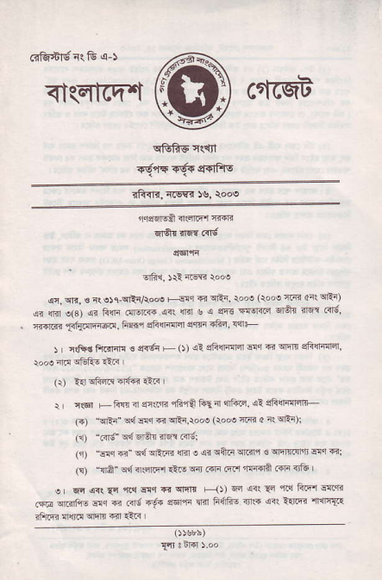
_{<t(4tTq"t} ctfcqA
^{q&RE} i{1ll
did6 6f. $6rFrs
rii{{, {cs<{ !s, \ooe
1qtr5s 4€t.Er iTFB
^{qrq{} rl!|3 'nd
5rfi1, _{Jr!} ^{iffi} r"'o
^{q, qn.} € r| ojr-qrir/rooo +-{ _{* ci{i, rolo} (rooe _{4{r 4rr} qEr) s? {li1 o(s) _{a? 1i6 .!FF{} ^{qrl} _{1rir s {} ^{qft} scor{rE dfq{ isii cird _{n-+l.c} ^{,l1hr{Ft41!.} Frmr dii{FlFr s'1!F .fii. !{+
! L rtr+d ft.<liiq € 4<6i ^{ts} _{O)} ^{ql} sFdimr d4 E wm efitnillrl
^{(r)} _{1€} ^{q1i4t!} df< _{{1r} I
_{r} ^{q(6l} +1i{ n @ffR rF fa i?l{ {Fiq. si sfrlFnErr (-) :sFa _{o4Fq 6} ^{qRi.roo!} (rod {d a rlqRi);
_{(3r)} ^{'i{g! q{q5tr} {fl Frtl
('r) "d.r <" ^{q4 qEi44} _{@ o 4r} ^{qiln} !m,l € !ii!E {rn eq di _{(s)} ^{-{4" q'l} sRrrF _{€o} ^{q{} ..F R.l nffi? .4la otu
_{e} qc ^{q<({n 'l.qwqsqtll} itFq?rFcllfttrEa.* _{lm} ^{q.{Fr-} sr € m' d€i 3r61ri rlm F{rftE 4rt4 6r llm {{llTr 3fr6r {w! orqin *r ri.r
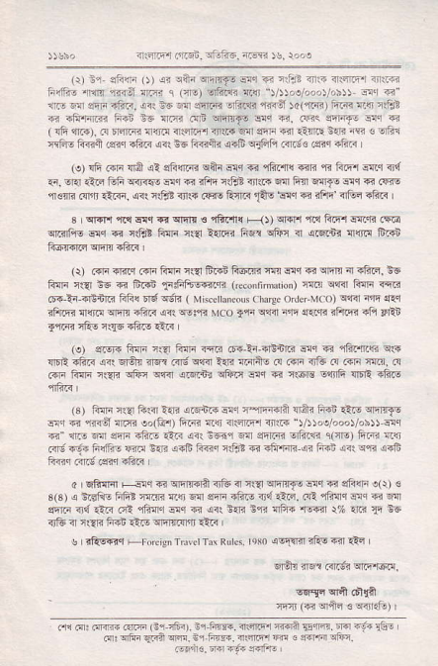
ar-@ m6n. _{trff@.} ^{qrev je,} Joo,
(r) _{nr} ^{qft1li} _{o)} 4r _{sft} ^{qrflrF} E{<r G 4{"? 3n5 il4lrr iftm _{F{tris afl} ^{,ri{61{r{r q} _{orEl} dfift$j eq )A)oe/..,)/ob))- dq @' rlre @ sqr rh... a{ is w enim ^{ErfirR} _{"rnff} M(crTi) fiFr lrq ifE +! +Fri'.ri F.n _{nE} ^{q]!i?} _{ffd} ^{qr1rf} _{dq €. ffis erFF E} ^{q} rq ( {fi {r4), .c _{Ermc<} ^{qfir} nlqr.r,r rn{. _{sll sm} ^{iFir} €n E l{R R . dfi! 'rFig _{li€:i Gn.r {Eri} ^{(rr} !E _{R{!ii} q.fr ^{qjFln} .{16€ ,?ir.r .ft<
.or !fi .4F 116 ,4! cF{rn sqi EI,r 6 ift4{ _{+ r} ^{'n} ft4{ wl {{ _{{r,} ^{iJlq} {lrc _{Gfi} ^{qir<.o} _{dq d iftr ist irnr.} ^{qnl} fill s!rf! an c .Frs 'ncrrrj ^{(nin} _{€Rn.} ^{qr!} i.!Et nr.r .F! _{ftfl.r} ,la! l-!q < ?PF 4ltq .ft< r
₃ ^{qrr} ri! _{{{q} ^{q qnfi} € ^{q&.'fi{} _{F<J)} ^{qr:!r,r} r1 Frq,t wan rqa ^{qrirft6} ar 6 r€! Rrji 4? t{.qi _{fiqr} ^{qftn} _{a} ^{qRn?} $m ffi
^{(t)} ..Iio.r.r.n1i{n{aftr.nFlmiF€{qF.qrr1lir?ft!r.i6 Fn]n cer i6 < ffi _{F:ffi@.,r,} (€o,nm{ion) lm ^{qrr<r} lillr ffi 6.-li-osnr.< _{Fl?r fi6} ^{q6ri} ( M iscerbnro* ^{cb} _{r. orrd-Mcol} ^{qqrn} fii d4r _{?Fritir il.m} ^{qrm} .F.? crr w$n Mco _{*,rn} ^{qlrir} iqr s..q< ?fi.B +1i fl:5 {,@ cFs irft .fi@ it<
^{(€)} 416r{ _{filri r(a FIri Ttir} (F4-!r-?En!.i ^{F,l €} _{"ift{.q} q. _{lnQ -h.< @{} ^{qr8tr} <lF .{s s{<r ::lr liaiE c! !!ri aC .! ..F nn. .! _{m liF c{{|r} ^{qftr qr.r} _{oei+r} ^{qFa} _{<!q} ^{q} r!68 -qnfri {lrR .fts
(s) Flri ner hl4 t{? aFnF sq {qreB {fa_r Flrn _{1lru} qrlTlrlg ^{qlr} ₆ ^{'rfli} d.ri eo(tu) ftB vq 4ri|.E'l rn.ir r/r)oo/ooo)/.h)J Elq -i" rr.o w sqri ift! ia.< <<t s61wr eftR ^{slft:B} lir!) FEB nc ed {6r F(F$ €d b{R <-F F<q {F.E _{< rFFr4R} ^{qr} _{FGn} qr. ^{q,r4} .!rF
o ' chE l-'c € _{sFF? {tu d +t} ^{q?a16} _{E.} ^{q dt@} _{".)} ' e _{3(3r} { _{s.dN} 1'tst :"@ ^{qa} 6'l r 6F., ad tt8, (!! ^{riaq} anc c @ sqr.i ir{ rlii _{.rl {i!l"l aq €} ^{qrr} _{E.R !'rr {F?} ^{'f@ r% {i?} _{{6} aF 4E ir nsi id _{1tF} ^{qnninn} 1!ir
s I res61 +Fortign rn€r rir R,r-. _{r$o} ^{q6iim} _{rFE} ^{qi} A.l ErSn _{rrsr .r|r6i} qrEre!,
cFa _{(T.} ^{qriin} € ^{qirEtu)} r
.!1 r, ilm .rrn Gr-:6i). Br F@. ilqfFr r{qn Effi. @ ^{-9{} rbi _{d!} qFn ^{qFn} !m. ni FF. {rffir @ 3 _{ffi} qfiic.
Fqnrc _{mr F6.} qdft.

